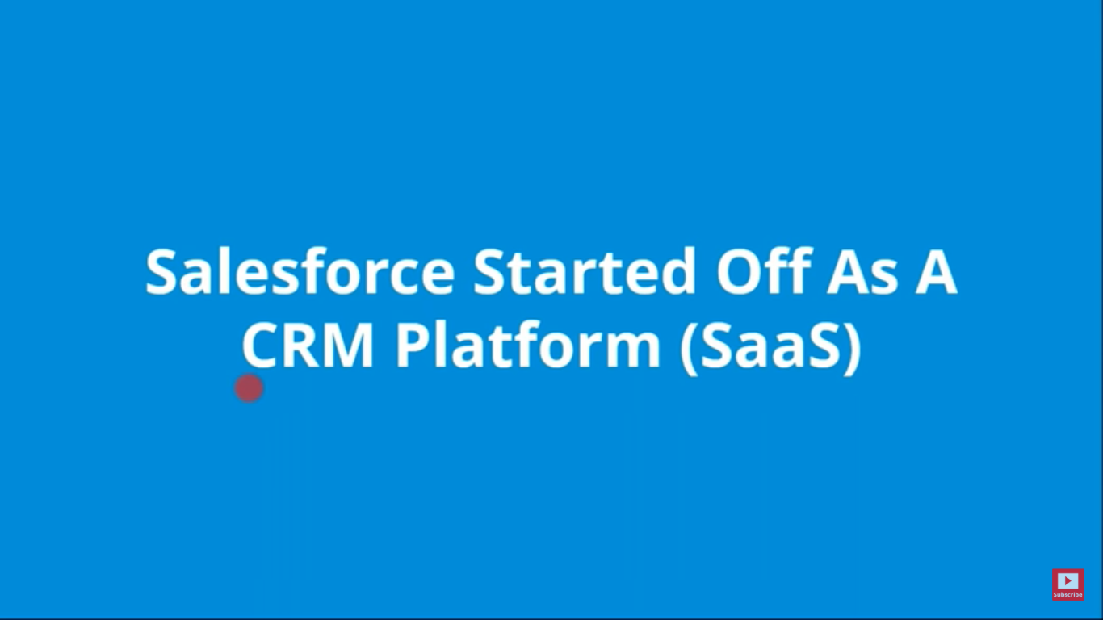

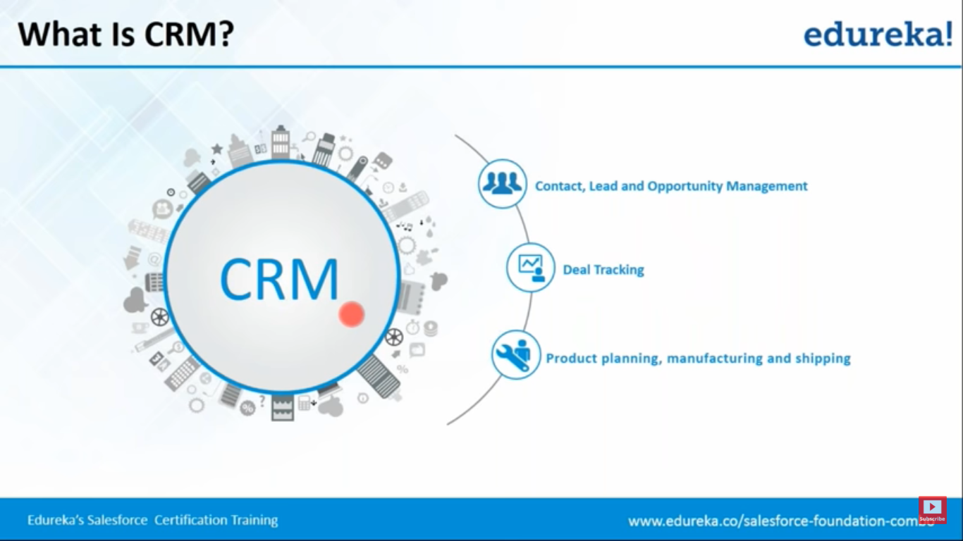

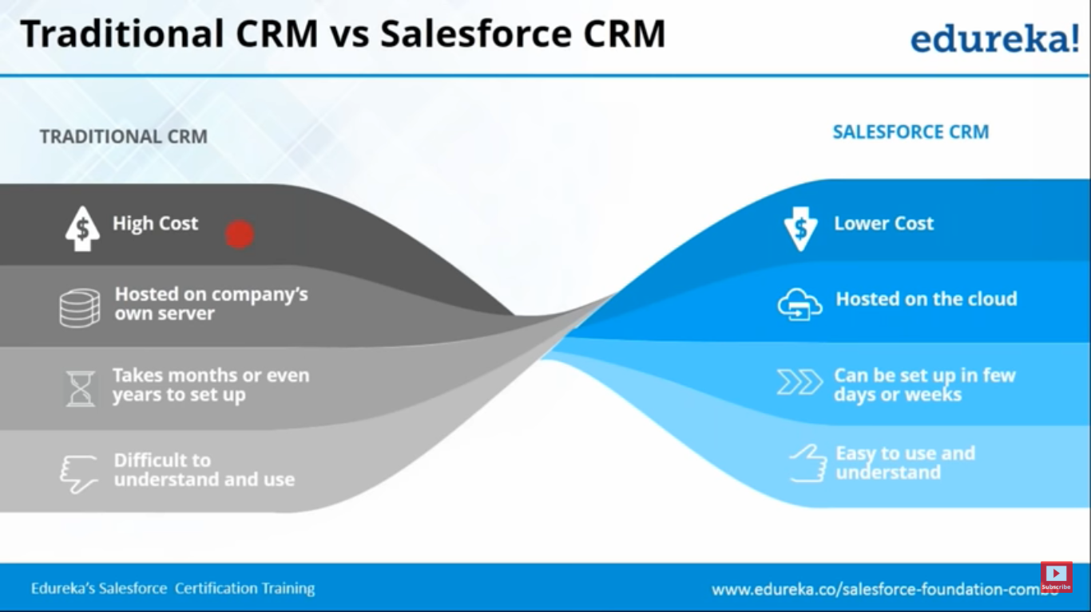

**Lowest Cost:** cheap because salesforce CRM was hosted on cloud so companies didn’t have to spend on the infrastructure and on the developer who would develop the application.

**Can be setup in few days or weeks:** Since applications are already developed by salesforce, company have to implement or customize as per their needs within few days or weeks.

**Easy to use and understand:** Since apps are developed by salesforce, and their developer team constantly works on the apps improvements based on the feedback received from their customers.

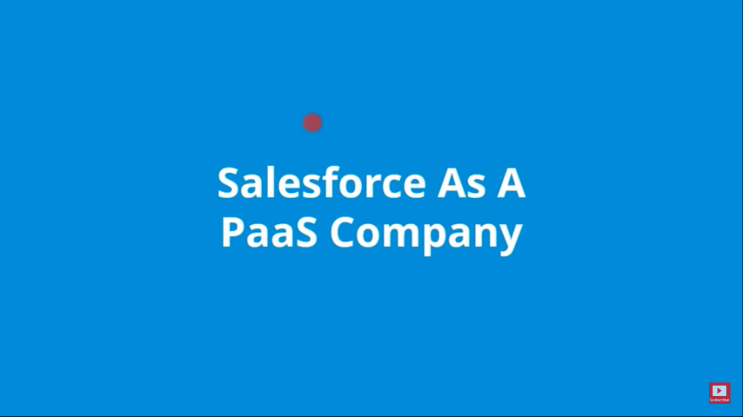

**SaaS:** Software as a service: If the company provide the service in the form of softwares.

Salesforce provided us the readymade CRM software, Salesforce.

**PaaS:** Platform as a service: If the company provide the service in the form of platform, on which we can develop own app or software.

Salesforce provided us a platform where we can develop our own applications and release that on the AppExchange to share with other people.

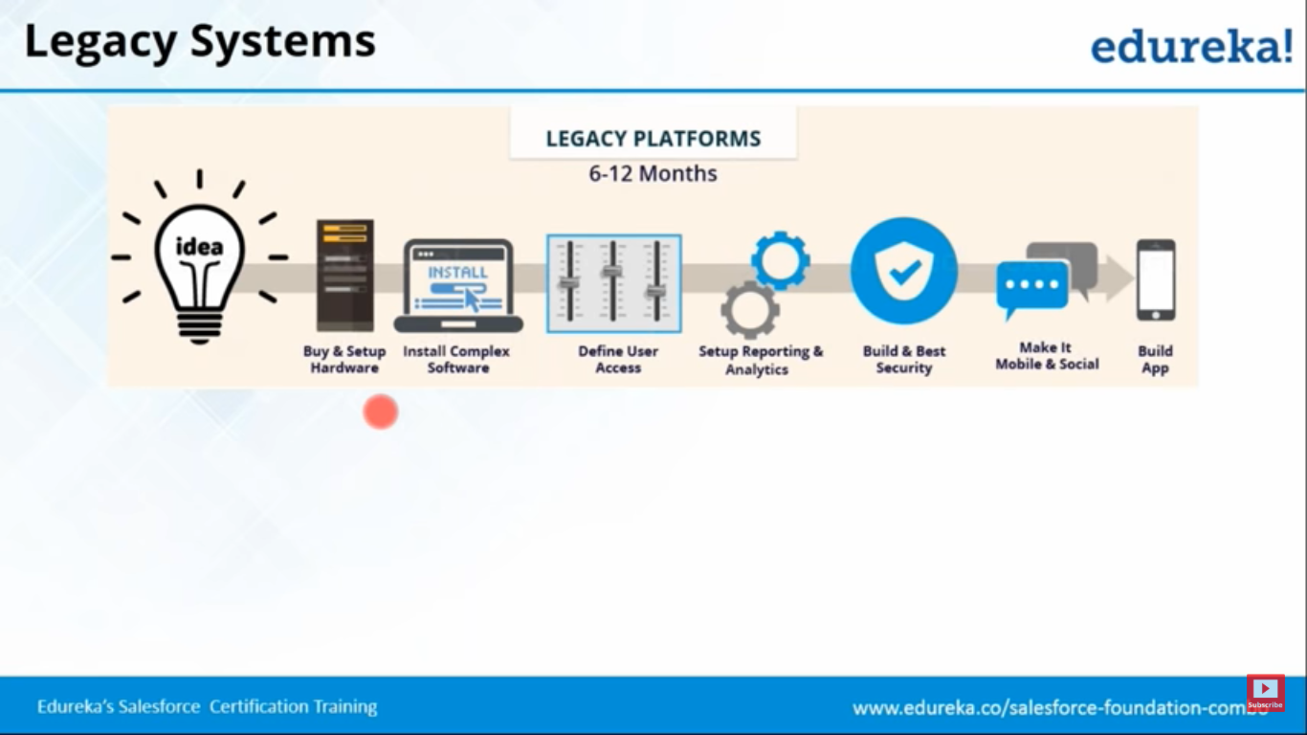

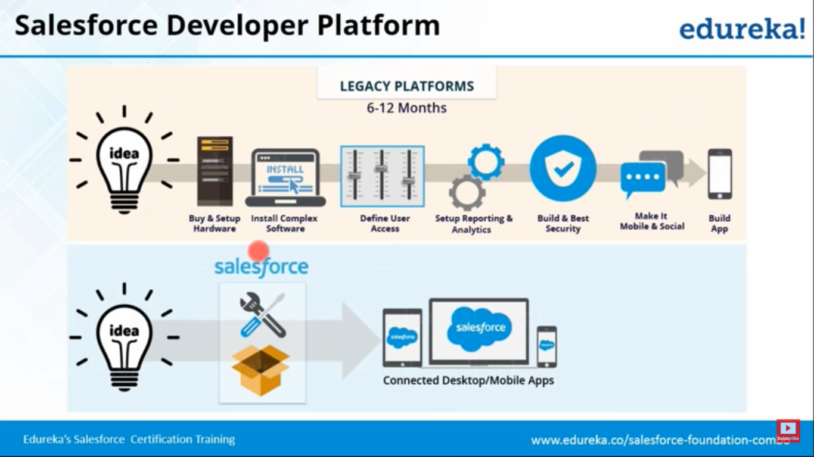

# Services and Products offred by Salesforce

Sales Cloud

Marketing Cloud

Service Cloud

Analytics Cloud

Community Cloud

App Cloud

Commerce Cloud

Health Cloud

IoT Cloud

Salesforce 1 Cloud

Chatter Cloud

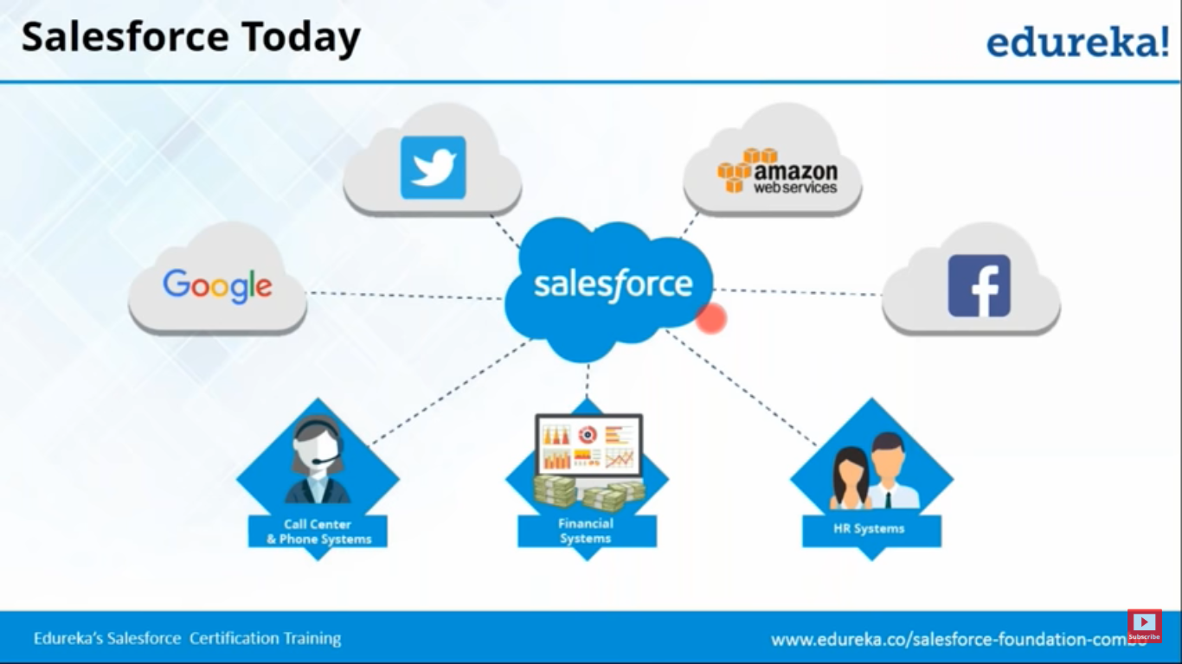

Applications are created on salesforce’s official platform i.e. Force.com.

Advantage with Salesforce is that, developers can create the apps and share with different companies across many geographies.

**Common requirements**

HR System’s:

To store employee records.

To track of payroll processes.

To track of the attendance of the employees.

Financial systems:

To track the transactions made.

To know buyer, seller details

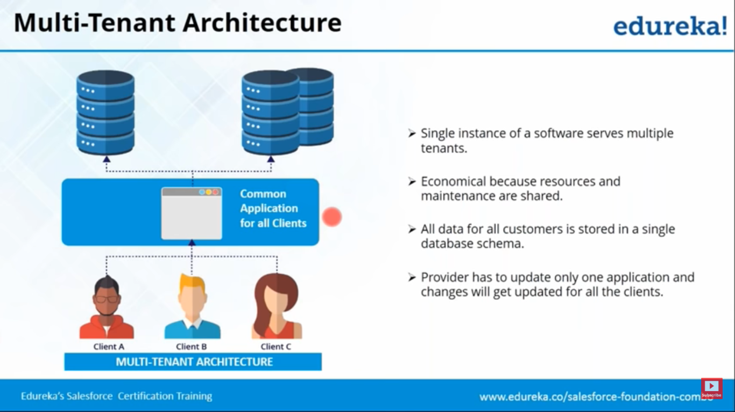

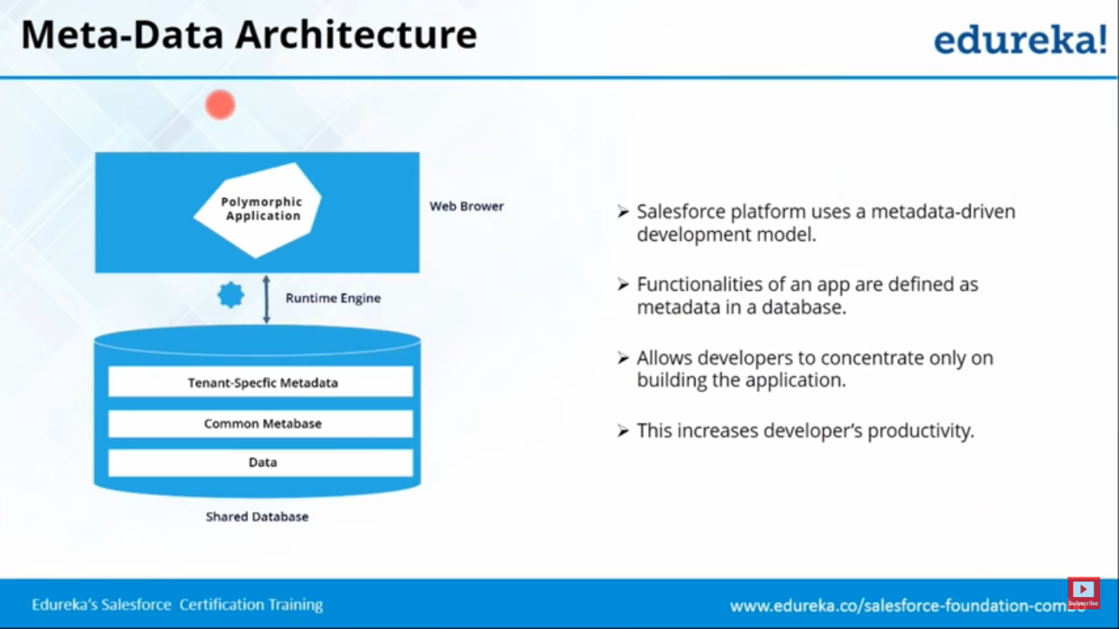

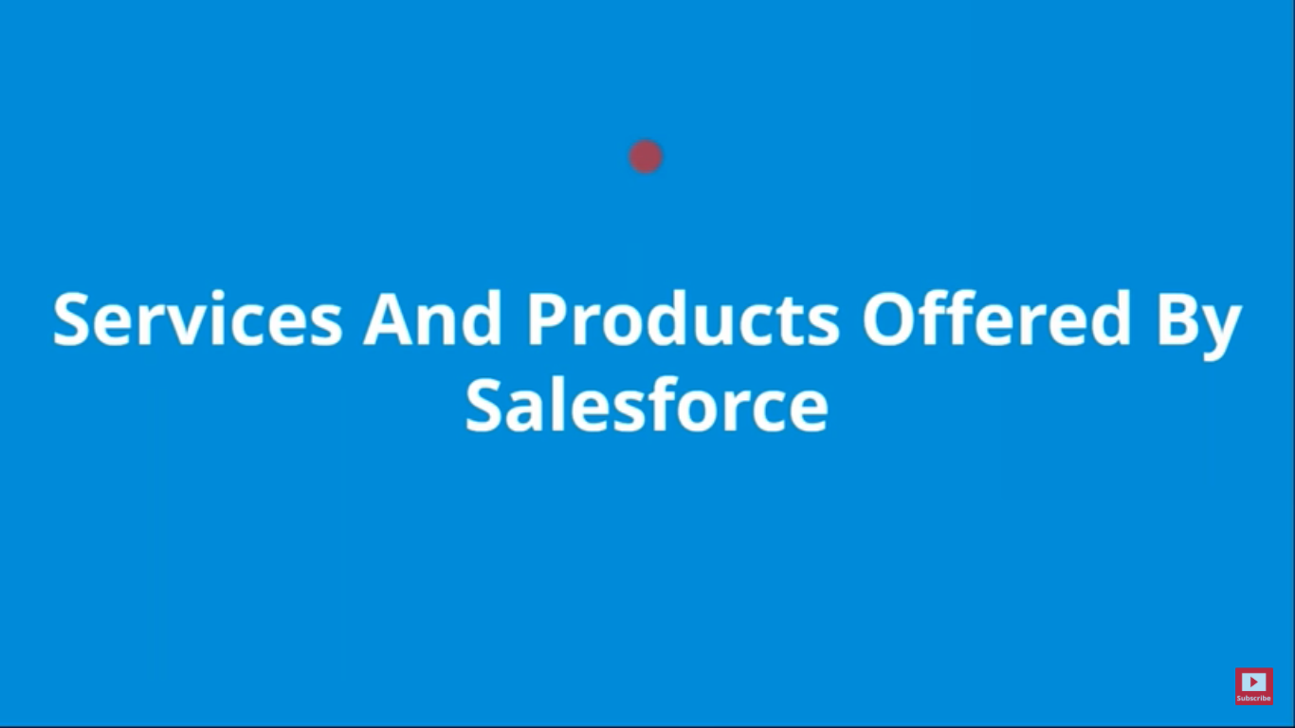

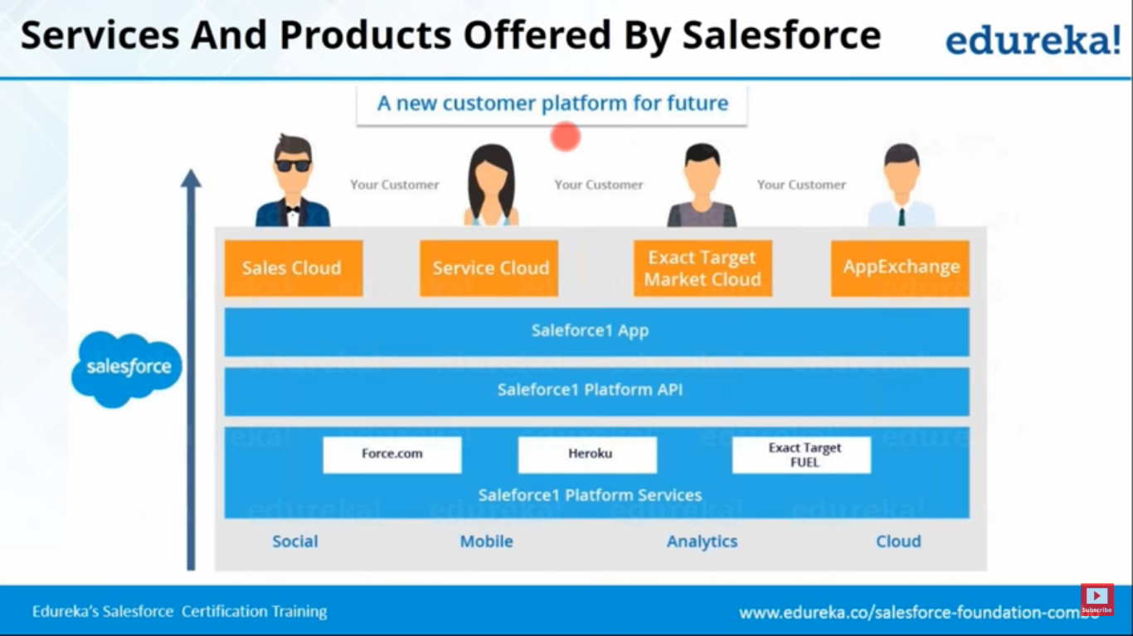

# HCL Use case Solutions:

